JANUARY 2021 WI WALK 10 th January at 10.30 am

Circular walk approximately 6 /8 miles long, 4 hours duration. Mixed terrain of tarmac, large stones and muddy paths. Involves a steep downhill section over large, loose stones.

Stalybridge Country Park – Harridge Pike – Carrbrook village – Heyheads – Miller Hey – returning via Tame River path and Huddersfield canal towpath to Stalybridge Country Park.

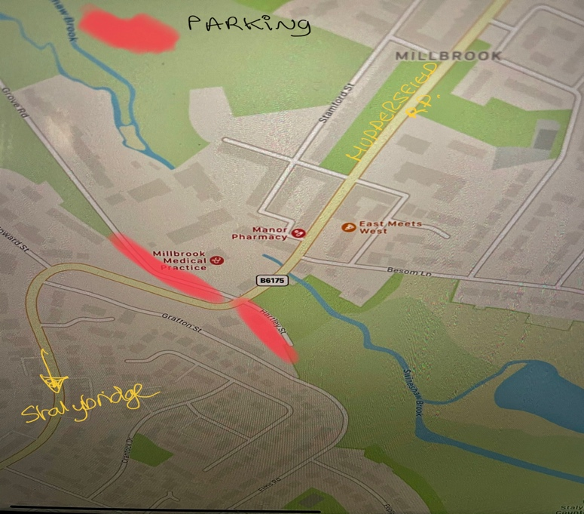
CAR PARKING

Oakgates car parking adjacent to Stalybridge Country Park (off Hartley Street SK15 3FH)
Additional parking found along Grove Road (SK15 3HR)
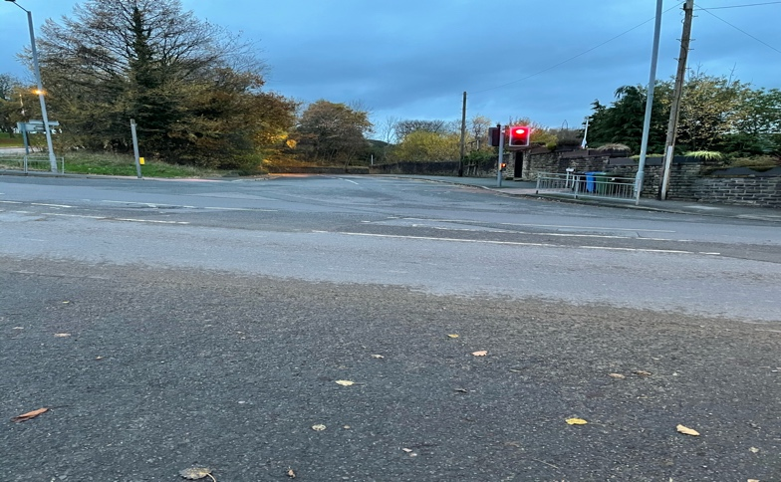

Start going upwards through Stalybridge Country Park to reach Walkerwood Reservoir.
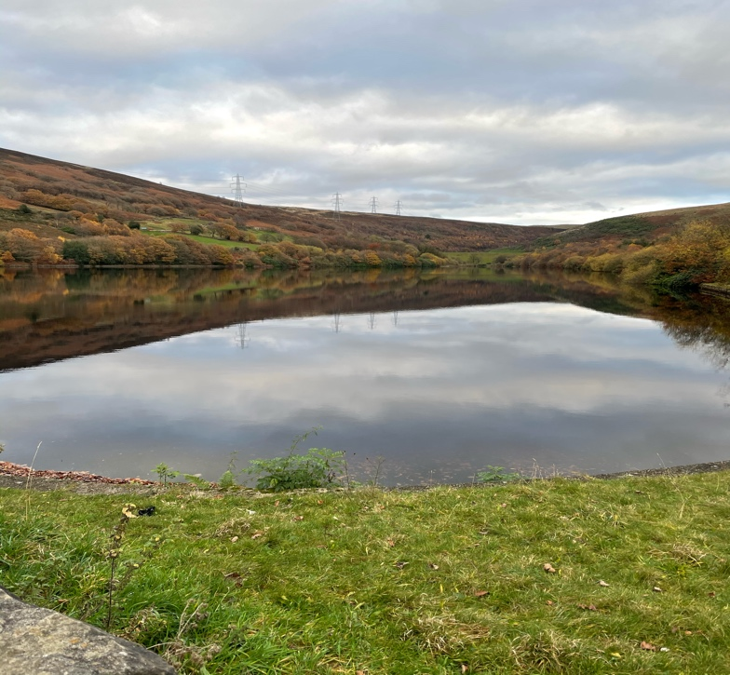
At the Dam of Walkerwood Reservoir continue upwards along tarmac road.

Pass through a metal turn gate and on past Brushes Reservoir.
Continue through open moorland to reach Lower and Upper Swineshaw Reservoir.

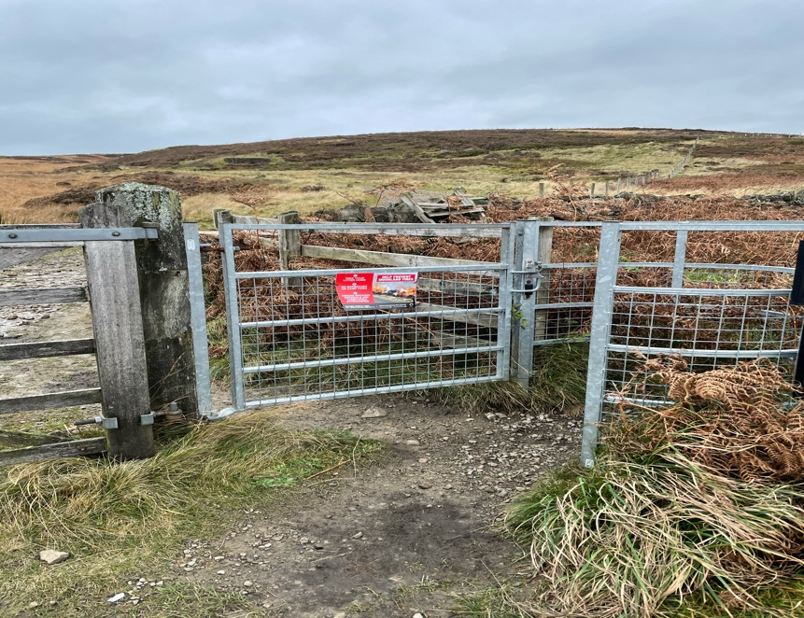
Turn LT at the start of the Upper Swineshaw Reservoir dam, pass through a metal gate and climb up onto Harridge Pike.

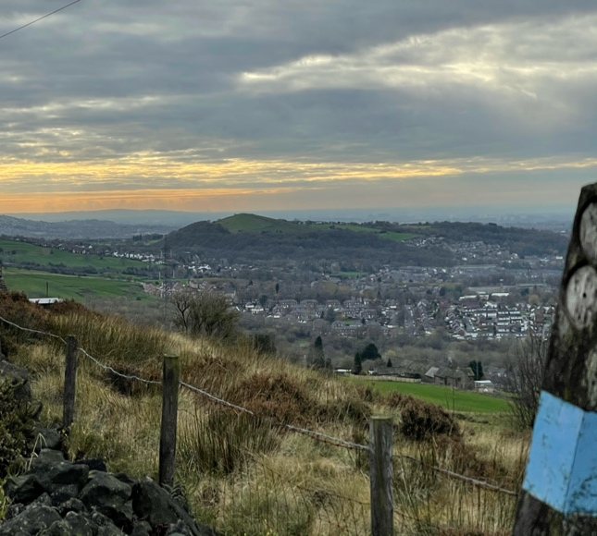
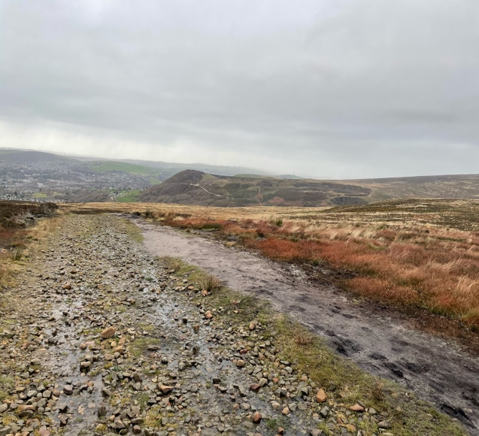
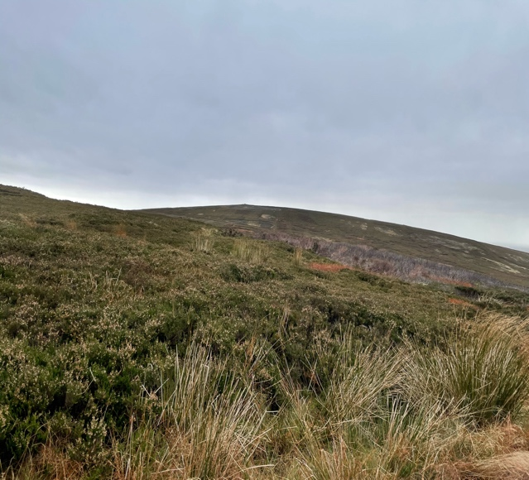
Highest point is marked by a cairn. Look out for white hares and views in all directions.

Descend to Carrbrook village duck pond (possible pick up point (SK15 3PH)
Head towards the Carrbrook bowling green and follow the brook (Carr Brook) though the valley towards Stamford Arms Pub.
Cautiously cross the Huddersfield (B6175) and head downhill through Heyheads towards Miller Hey, passing Mossley cemetery on route.
Be careful as electrical fencing protects farm animals on one side.
Turn LT at Miller Hey (possible pick up point OL5 9NZ) along muddy track to the end, then turn RT and going downhill towards canal.
When a large brick wall is encountered pass through a wooden gate on your RT side and follow track through woodland to join the canal towpath.
As you join the canal towpath you will see a lock gate. Cross this lock gate to be on the other side of the canal and turn LT. Walk until you reach the canal tunnel entrance.
Climb steep steps to get above the tunnel mouth. Turn RT and follow path down to River Tame.
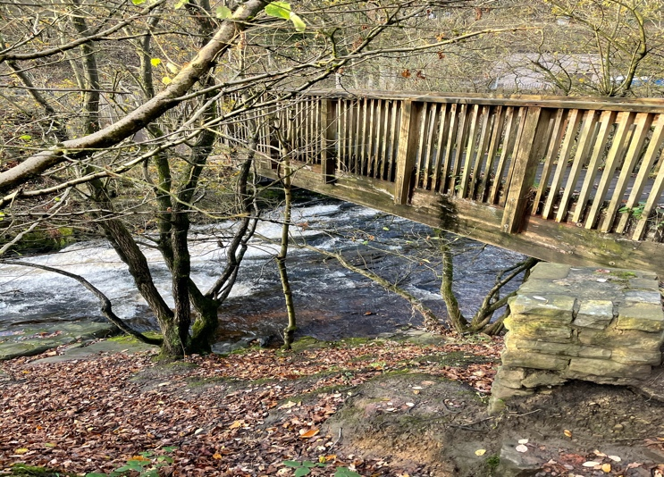
Foot bridge crosses the River Tame leading to Wakefield Road. Pause to view the waterfall below.

Continue by along the river path which shortly forks LT uphill over the tunnel mouth.
Turn RT immediately after crossing tunnel mouth through a short section of woodland to the canal towpath and head in the direction of Stalybridge.
Continue along towpath until Grove Road is reached.
At this point leave the towpath by veering LT to join Grove Road.
Continue along Grove Road until Huddersdfield Road is encountered and Oakgates car parking area.

Hope you enjoyed the walk.

