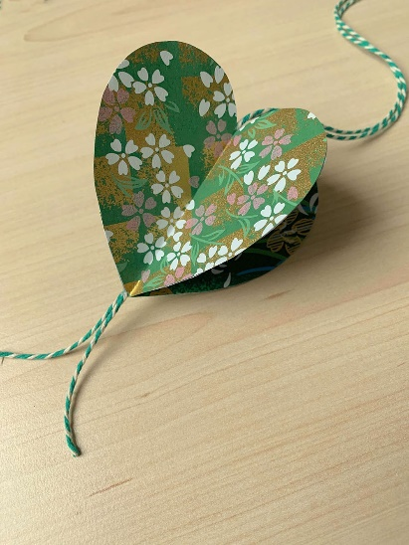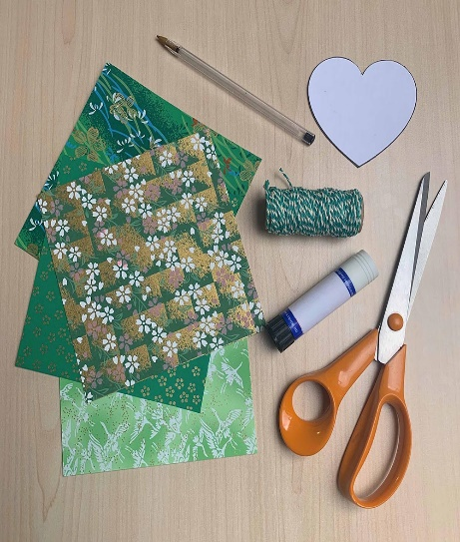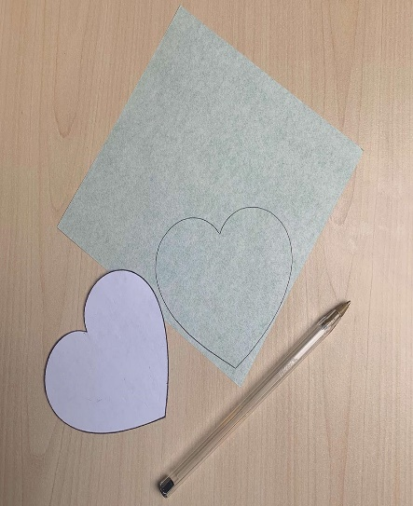
You will need:
- Four coordinating designs of green origami paper – alternatively up-cycle wrapping paper or colour in your own designs on scrap paper
- Heart template [download here]
- Thin card
- Green bakers twine
- Paper scissors
- Pen or pencil
- Glue stick
- Scrap paper
.
- Download the heart template and print out at 100%. Stick the printed template on to a piece of thin card and cut out the shape. Using the reinforced template draw around the shape on to the wrong side of each origami paper.
- Cut out the four hearts shapes.
- With right sides facing, fold each heart shape in half, keeping the edges level. Crease firmly along the folds.
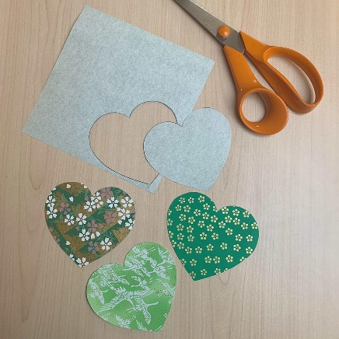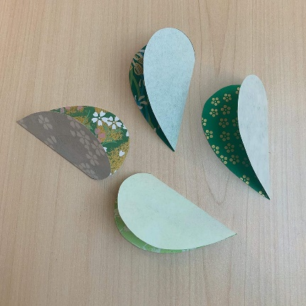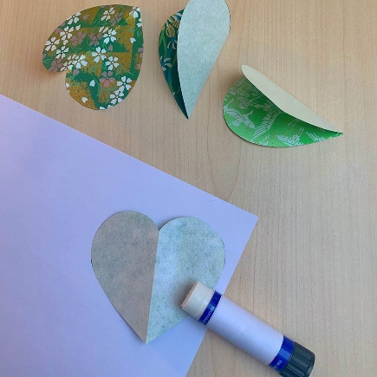

- Using scrap paper to protect your table; take one of the heart pieces and with the wrong side uppermost, spread glue onto one half of the shape.

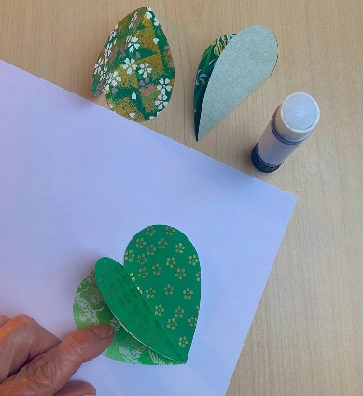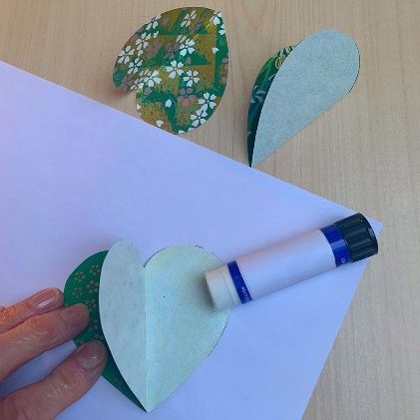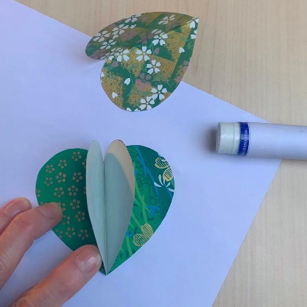

- Take a second heart and stick the two pieces together, with wrong sides facing and edges level
- Spread glue on to the reverse side of one half of the joined hearts
- Attach a third piece in the same way.
- Spread glue on the reverse side of one half of the joined hearts and attached the fourth heart. You should now have all the heart pieces stuck together, with just two sections remaining unglued.

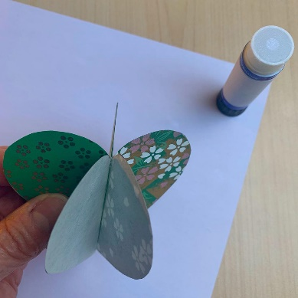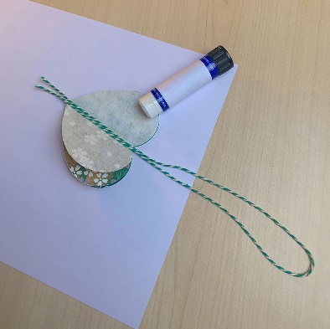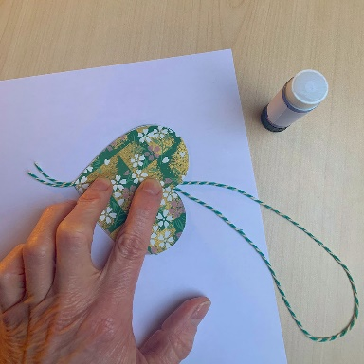

- Cut a length of bakers twine for the hanging loop and fold it double. Spread open the last two sections of the joined hearts and place the doubled bakers twine down the centre with the cut ends level at the bottom.
- Spread glue on one of the remaining heart sides and stick the two final sections together, trapping the Bakers twine down the centre.

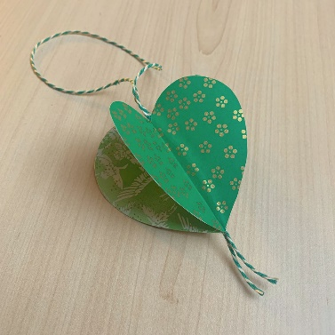

- Gently open out your heart ‘petals’, your four-sided Oriental hanging heart is now complete and ready for you to hang.

